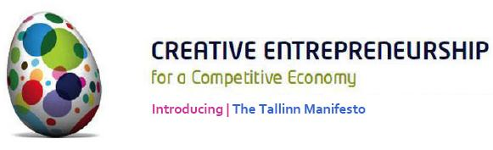

December 2011

Introducing the Tallinn Manifesto

Dear All,

The Tallinn Manifesto calls for a re-think on how we approach strategy and action across the Creative Economy. It sets out an agenda for a refreshed and re-invigorated approach to knowledge development, collaboration, strategy and policy – across Europe and internationally.

It introduces a set of themes which will help different localities to maximise their distinctive potential; and it frames questions which we should all have strong answers for if we are serious about developing a Creative Economy which is productive, value-adding, sustainable, resilient, inclusive and fair.

Read the Manifesto

The Tallinn Manifesto – a Tool for Strategic Development across the Creative Economy
The Tallinn Manifesto is the product of a major international conference on Creative Entrepreneurship - held in Tallinn in October 2011: www.creativeestonia.eu
It is co-created by delegates and speakers at the conference - with 25 nationalities represented overall.

It is written by Dr Tom Fleming - Director of TFCC: www.tfconsultancy.co.uk
With the economic crisis, plus crises in confidence and identity, we need a rethink on the role and value of the Creative Economy and a refreshed approach to policy and strategy. The purpose of the Tallinn Manifesto is therefore to provide a stimulus and focus for debate, which then develops as a driver for strategy and action across the world.

We look forward to exploring the implications of this with you.

Read the Manifesto

For more information, contact:

tom fleming / creative consultancy /
email / info@tfconsultancy.co.uk
telephone / +44 (0) 207 430 085
web / www.tfconsultancy.co.uk
twitter / @tfconsultancy

